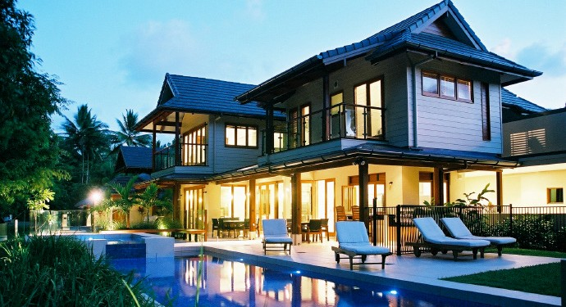

**Welcome to our home!**

**Contact:**

**Your name here**

**+1.333.333.3333**

**member@example.com**

HOUSE MANUAL



PROPERTY NAME HERE

City, State, Country



**Welcome to our home!**

This is a wonderful section to give a brief introduc- tion and overview of the property/destination for your guests. In broad strokes, describe the ameni- ties and highlights of the property.

**About Us**

Include a small segment about you and your fam- ily! It’s those small personal touches that really make a guest feel at home. You could even include a picture of yourself in the section above.

Make yourself at home!

8

ARRIVAL/DEPARTURE

**WIFI/INTERNET**

ID:

Password:

**Check-in time**

Let your guest know what time he/she should plan on arriving at your property.

**Directions**

Some properties are off the grid. If your home is difficult to find via GPS, be sure to describe, in great detail, the directions to your property. You can also provide direct GPS coordinates here.

**Parking**

Parking can be confusing if you’re part of a larg- er affiliate/resort property or complex. Let your guests know where their car (if they have one) will be safe.

**Airport/local transportation**

If your guest isn’t bringing a car, be sure to com- municate alternative ways to reach your house. Include local car rental, bus, taxi or shuttle services.

**Check-out time**

Let your guests know what time they should de- part. Include any other departure procedures here.

ABOUT OUR HOME

**DESCRIPTION**

Give a detailed description of your home. Could be the same description listed in your property page.

**STAFF/TIPPING PROCEDURES:**

Let your guests know if your staff requires certain fees or tips. It might also be prudent to include tipping customs for the destination as a whole.

**AMENITIES**

Give detailed instructions for featured amenities including any of the following:

**Pool**

Usage instructions.

**Hot Tub**

Usage instructions.

**Sauna**

Usage instructions.

**Game Room**

Usage instructions.

**In-home theater**

Usage instructions.

**Resort amenities**

Usage instructions.

**Access to local Golf clubs/Country clubs**

Usage instructions.

APPLIANCES/FEATURES

**Here are some common appliances that often need explaining:**

**AC/Central Heating**

Quick explanation of usage...

**Sink/Garbage Disposal**

Quick explanation of usage...

**Oven/Range**

Quick explanation of usage...

**Dishwasher**

Quick explanation of usage...

**Coffee Machine/Espresso Machine**

Quick explanation of usage...

**Fireplace**

Quick explanation of usage...

**Laundry**

Quick explanation of usage...

**Security system**

Quick explanation of usage...

**Television/Streaming system/DVD player**

Quick explanation of usage...

**WIFI Router/Modem**

Quick explanation of usage...

APPLIANCES/FEATURES

**Here are some common appliances that often need explaining:**

**Shower/Bathtub**

Quick explanation of usage...

**Garage Door**

Quick explanation of usage...

**Grill**

Quick explanation of usage...

**Cleaning Supplies**

Quick explanation of usage...

**Smoke Detectors**

Quick explanation of usage...

**Bidet**

Quick explanation of usage...

**Pool**

Quick explanation of usage...

**Sound/Music System**

Quick explanation of usage...

**Refrigerator**

Quick explanation of usage...

**Water purifier**

Quick explanation of usage...

GUEST CONTACTS

**Housekeeping**

Enter contact information here...

**Maintenance Staff**

Enter contact information here...

**Security**

Enter contact information here...

**THIRDHOME Member Experience Team** [email: memberexperience@thirdhome.com](mailto:memberexperience@thirdhome.com) phone: 615-454-2329

LOCAL INFORMATION

**Weather**

Give a brief overview of the weather in your area...

**Restaurants**

Give a brief overview of your favorite local restuar- ants...

**Local Activities**

List your favorite local hobbies and activities...

**Local Transportation**

Taxis, busses, ridesharing, ski-lifts, gondolas, etc.

COMMUNITY CONTACTS

**Airport**

Enter address and contact information here...

**Bank**

Enter address and contact information here...

**Church**

Enter address and contact information here...

**Gas Station**

Enter address and contact information here...

**Grocery**

Enter address and contact information here...

**Hospital**

Enter address and contact information here...

**Pharmacies**

Enter address and contact information here...

**Police Station**

Enter address and contact information here...

**PLEASE LEAVE A REVIEW**

We’d love to hear your feedback! Please leave us a review on the MyTHIRD**HOME** Dashboard.